Micro Economics
Home Work 2
Chapters 6-9
PART II: THE MARKET SYSTEM
Following are 40 multiple choice questions, each worth 2.5 points. Choose the answer you think most correct. If you are uncertain about an answer, write next to the question why you think your choice is correct.
Chapter 6 Household Behavior and Consumer Choice

1) Jane has $500 a week to spend on clothing and food. The price of clothing is $25 and the price of food is $10. The clothing and food pairs in Jane's choice set include ________ units of clothing and ________ units of food.
A) 50; 50
B) 20; 50
C) 15; 25
D) 8; 30

2) Jane has $500 a week to spend on clothing and food. The price of clothing is $25 and the price of food is $10. Jane spends her entire income when she purchases ________ units of clothing and ________ units of food.
A) 10; 10
B) 25; 5
C) 12; 20
D) 16; 8

3) Jim has $600 a week to spend on clothing and food. The price of clothing is $30 and the price of food is $5. The clothing and food pairs in Jim's choice set include ________ units of clothing and ________ units of food.
A) 20; 50
B) 15; 70
C) 10; 60
D) 0; 200

4) Jane has $500 a week to spend on clothing and food. The price of clothing is $25 and the price of food is $10. What is the equation for Jane's budget constraint?
A) ($25 × Clothing) × ($10 × Food) < $500
B) $25 × Clothing + $10 × Food ≥ $500
C) ($25 × Clothing) / ($10 × Food) = $500
D) $25 × Clothing + $10 × Food = $500

5) Ted has $600 a week to spend on clothing and food. The price of clothing is $30 and the price of food is $5. What is the equation for Ted's budget constraint, assuming he spends his entire budget?
A) $30 × Clothing + $5 × Food < $600
B) $30 × Clothing + $5 × Food ≤ $600
C) $30 × Clothing + $5 × Food > $600
D) $30 × Clothing + $5 × Food = $600

Refer to the information provided in Figure 6.1 below to answer the question(s) that follow.

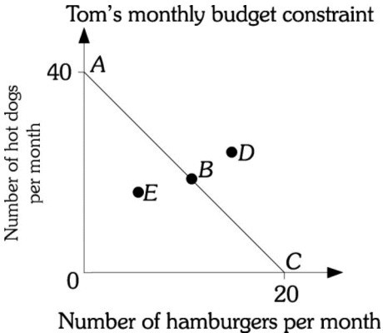
Figure 6.1

6) Refer to Figure 6.1. Assume Tom is on budget constraint AC and the price of a hamburger is $4.00. Tom's monthly income is
A) $20.
B) $60.
C) $80.
D) $100.

7) Refer to Figure 6.1. Assume Tom is on budget constraint AC and the price of a hot dog is $2.00. Tom's monthly income is
A) $40.
B) $60.
C) $80.
D) $100.

Refer to the information provided in Figure 6.2 below to answer the questios that follow.

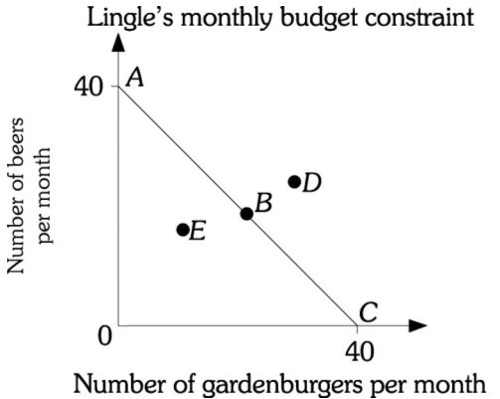
Figure 6.2

8) Refer to Figure 6.2. Assume Mr. Lingle is on budget constraint AC. If the price of a gardenburger is $6, Mr. Lingle's monthly income is
A) $24.
B) $60.
C) $200.
D) $240.

9) Refer to Figure 6.2. Assume Mr. Lingle is on budget constraint AC. If the price of a gardenburger is $9, Mr. Lingle's monthly income is
A) $40.
B) $80.
C) $180.
D) $360.

10) Hector has $2,000 a month to spend on clothing and food. The price of clothing is $50 and the price of food is 20. The clothing and food pairs in Hector's choice set include ________ units of clothing and ________ units of food.
A) 100; 100
B) 40; 100
C) 30; 50
D) 16; 60

Chapter 7 The Production Process: The Behavior of Profit-Maximizing Firms

1) Total revenue minus total cost is equal to
A) the rate of return.
B) marginal revenue.
C) profit.
D) net cost.

Refer to the information provided in Figure 7.1 below to answer the following question(s).

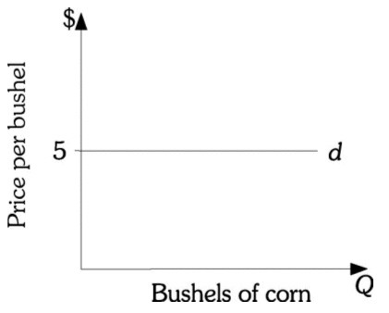
Figure 7.1

2) Refer to Figure 7.1. This corn producer produces 100 bushels of corn and sells each bushel at $5. The cost of producing each bushel is $2. This corn producer's total revenue is ________ and profit is ________.
A) $200; $300
B) $300; $200
C) $500; $200
D) $500; $300

3) Refer to Figure 7.1. This corn producer earns a total revenue of $900. Each bushel of corn is sold for $5. This corn producer must be selling ________ bushels of corn.
A) 180
B) 450
C) 900
D) 4,500

4) Refer to Figure 7.1. A corn producer's profit is $200 and is producing 100 bushels of corn. Then he must have a cost per bushel of
A) $1.
B) $2.
C) $3.
D) $4.

5) Refer to Figure 7.1. A corn producer produces 80 bushels of corn and sells each bushel at $5. The cost of producing each unit bushel is $2. This corn producer's total revenue is ________ and profit is ________.
A) $160; $0
B) $240; $80
C) $400; $240
D) $400; $160

6) The Wax Works sells 400 candles at a price of $10 per candle. The Wax Works' total costs for producing 400 candles are $500. The Wax Works' economic profit is
A) -$100.
B) $3,500.
C) $4,500.
D) indeterminate from this information.

7) The Wax Works sells 400 candles at a price of $6 per candle. The Wax Works' total costs for producing 400 candles are $2,500. The Wax Works' economic profit is
A) -$100.
B) $0.
C) $2,400.
D) $2,500.

8) Perfectly competitive firms must make all of the following decisions except
A) how much output to supply.
B) which production technology to use.
C) how much of each input to demand.
D) what price to charge for their output.
9) Economic costs
A) include both a normal rate of return on investment and the opportunity cost of each factor of production.
B) are equal to the direct costs of hiring all factors of production.
C) are the opportunity cost of each factor of production minus any interest charges paid on borrowed funds.
D) are equal to total revenue minus accounting profit.

10) The Sweet Success Bakery sells 800 cakes at a price of $20 per cake. Its total economic costs for producing 800 cakes are $4,800. The Sweet Success Bakery's economic profits are
A) $4,800.
B) $11,200.
C) $16,000.
D) indeterminate from this information.

Chapter 8 Short-Run Costs and Output Decisions

1) In the short run
A) existing firms do not face limits imposed by a fixed input.
B) all firms have costs that they must bear regardless of their output.
C) new firms can enter an industry.
D) existing firms can exit an industry.

2) Which type of cost does not depend on a firm's output?
A) fixed cost
B) variable cost
C) total cost
D) marginal cost

3) Which type of cost does depend on a firm's output?
A) variable cost
B) total cost
C) marginal cost
D) all of the above

4) Economists usually assume that ________ is a fixed input in the ________ run.
A) labor; short
B) capital; short
C) labor; long
D) capital; long

5) Total variable cost ________ as output increases, and total fixed cost ________ as output increases.
A) increases; increases
B) increases; decreases
C) increases; does not change
D) does not change; does not change

6) The formula for total fixed cost is
A) TFC = TC + TVC.
B) TFC = TVC -TC.
C) TFC = TC/TVC.
D) TFC = TC -TVC.

7) Total cost is calculated as
A) the sum of total fixed cost and total variable cost.
B) the product of average total cost and price.
C) the sum of all the firm's explicit costs.
D) the sum of average fixed cost and average variable cost.

Refer to the information provided in Figure 8.1 below to answer the questions 9 & 10 that follow.

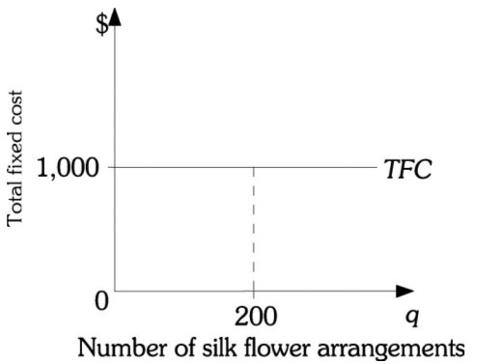
Figure 8.1

9) Refer to Figure 8.1 above. The total fixed costs for Cyndy's Floral Arrangements are $1,000. If Cyndy's Floral Arrangements produces 200 silk flower arrangements, the average fixed costs are
A) $0.20.
B) $5.
C) $20.
D) $200.

10) Refer to Figure 8.1 above. If Cyndyʹs Floral Arrangements produces 100 silk flower arrangements, the average fixed costs are
A) $0.10.
B) $10.
C) $1,000.
D) There is not enough information in the graph to answer this question.

Chapter 9 Long-Run Costs and Output Decisions
1) Assume firms break even in an industry. New firms ________ attracted to the industry and current ones ________ exiting it.
A) are not; are not
B) are not; are
C) are; are not
D) are; are

2) Firms that are "breaking even" are
A) earning zero economic profits.
B) earning less than a normal rate of return.
C) shutting down in the short run.
D) All of the above are correct.

3) In the short run, firms earning a profit will want to ________ their profits while firms suffering losses will want to ________ their losses.
A) maximize; maximize
B) maximize; minimize
C) minimize; maximize
D) minimize; minimize

4) In the short run
A) all firms that earn a loss will shut down.
B) if current firms are earning a profit, new firms will enter the industry.
C) firms act to minimize losses or maximize profits.
D) All of the above are correct.

Refer to Scenario 9.1 below to answer the questions 9-10 that follow.

SCENARIO 9.1: Amy borrowed $20,000 from her parents to open a bagel shop. She pays her parents a 5% yearly return on the money they lent her. Her other yearly fixed costs equal $9,000. Her variable costs equal $30,000. In her first year, Amy sold 40,000 dozen at a price of $1.50 per dozen.

5) Refer to Scenario 9.1. Amy's total fixed costs equal
A) $1,000.
B) $9,000.
C) $10,000.
D) $21,000.

Refer to Scenario 9.3 below to answer the questions 6-8 that follow.

SCENARIO 9.3: Investors put up $520,000 to construct a building and purchase all equipment for a new restaurant. The investors expect to earn a minimum return of 10 per cent on their investment. The restaurant is open 52 weeks per year and serves 900 meals per week. The fixed costs are spread over the 52 weeks (i.e. prorated weekly). Included in the fixed costs is the 10% return to the investors and $1,000 per week in other fixed costs. Variable costs include $1,000 in weekly wages and $600 per week for materials, electricity, etc. The restaurant charges $5 on average per meal.

6) Refer to Scenario 9.3. The normal return to the investors on a weekly basis is
A) $600.
B) $1,000.
C) $3,600.
D) $4,500.

7) Refer to Scenario 9.3. Total fixed costs per week are
A) $1,000.
B) $2,000.
C) $3,000.
D) $4,500.

8) Refer to Scenario 9.3. Total variable costs per week are
A) $600.
B) $1,000.
C) $1,600.
D) $2,000.

Refer to Scenario 9.4 below to answer the question(s) that follow.

SCENARIO 9.4: Sponsors invest $100,000 in a new deli on the promise that they will earn a return of 10% per year on their investment. The deli sells 52,000 sandwiches per year. The deli's fixed costs include the return to investors and $42,000 in other fixed costs. Variable costs consist of wages ($1,000 per week) plus materials, electricity, etc. ($2,000 per week). The deli is open 52 weeks per year.

9) Refer to Scenario 9.4. The annual fixed costs of the deli are
A) $10,000.
B) $42,000.
C) $52,000.
D) $156,000.

10) Refer to Scenario 9.4. The annual total costs of the deli are
A) $42,000.
B) $52,000.
C) $156,000.
D) $208,000.

