Financial Statement Analysis
HW 2
Chapters 4, 5 and 6

Following are 33 questions, each worth 3 points. Highlight or circle the answer you think most correct.

Chapter 4
1. | Which of the following would rarely be classified as a current asset?
  A. | Prepaid insurance
  B. | Goodwill
  C. | Marketable securities
  D. | Work-in-process

2. | Which of the following would not be classified as a current asset?
  A. | Inventory
  B. | Accounts payable
  C. | Accounts receivable
  D. | Prepaid expenses

3. | An asset is considered to be liquid if:
  A. | it is readily converted into a fixed asset.
  B. | it is an intangible asset.
  C. | it is readily converted into cash.
  D. | it is part of retained earnings.

4. | Analysis of a company's assets will help evaluate its:  I. liquidity.  II. solvency.  III. operational capacity.  IV. financing ability.
  A. | I, II, III, and IV
  B. | I, II, and IV
  C. | II, III, and IV
  D. | I, II, and III
5. | For Control Furniture Co.,  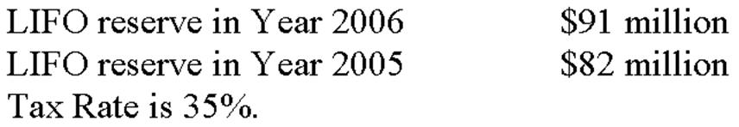  To restate Year 2006 LIFO inventories to a FIFO basis, we use the following analytical entry:  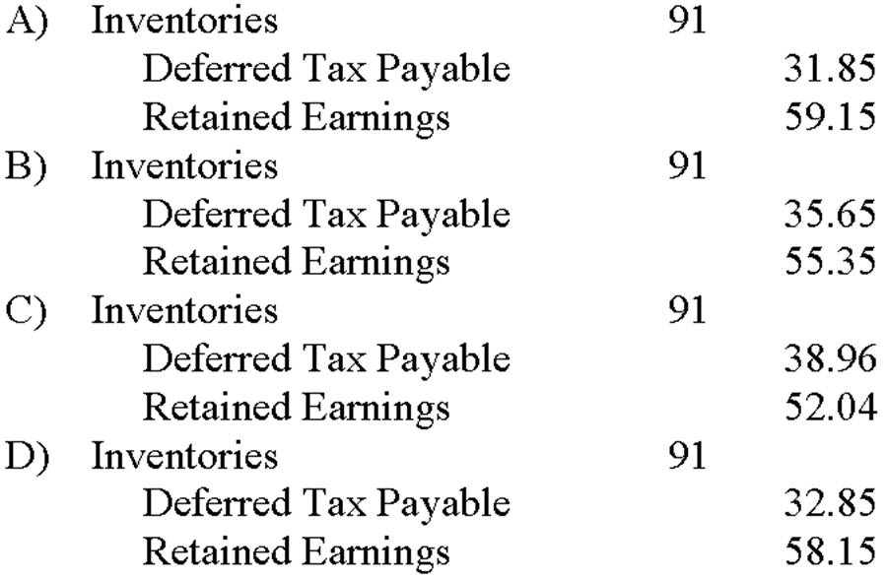
  A. | Option A
  B. | Option B
  C. | Option C
  D. | Option D

The following information can be found in ABC Co.'s financial statements.
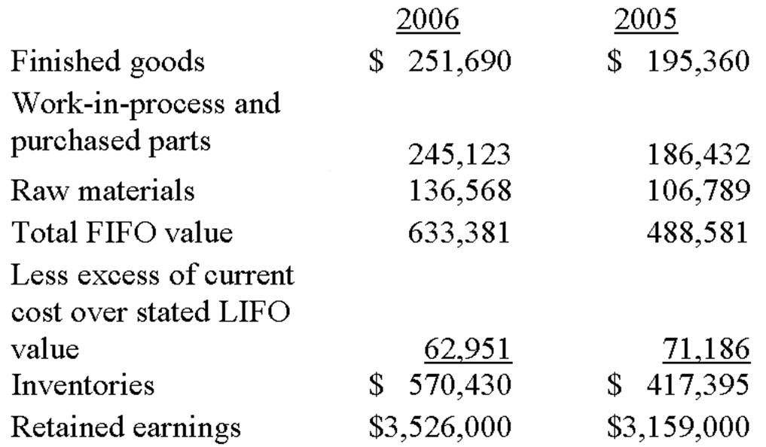
Assume a tax rate of 35%. Inventories valued using the LIFO method represented approximately 80% of consolidated inventories.

6. | What will be the value of inventory for 2006 if ABC used FIFO valuation?
  A. | $633,485
  B. | $570,430
  C. | $633,381
  D. | $488,581

7. | What will be the retained earnings for 2006 if ABC used FIFO valuation?
  A. | $3,205,271
  B. | $3,566,918
  C. | $3,893,000
  D. | $4,096,430

8. | What will be the retained earnings for 2005 if ABC used FIFO valuation?
  A. | $3,205,271
  B. | $3,566,918
  C. | $3,893,000
  D. | $4,096,430

9. | The use of LIFO rather than FIFO for inventory costing under normal economic conditions results in:  I. lower net income.  II. higher total assets.  III. higher retained earnings.  IV. unchanged retained earnings.
  A. | II and III
  B. | I, II, and IV
  C. | I only
  D. | I and IV

10. | Which of the following is not a common characteristic of a company choosing to use LIFO rather than FIFO?
  A. | Higher cost of goods sold
  B. | Higher variability in inventory balances
  C. | Greater expected tax savings
  D. | Larger in size

11. | Financial Statements of ABC Corp. indicates that ending inventory levels in 2005 and 2006 were $200,000 and $350,000 respectively. Cost of goods sold for 2005 and 2006 were $1,900,000 and $2,200,000 respectively. Purchases in 2006 were:
  A. | $1,950,000
  B. | $2,150,000
  C. | $2,350,000
  D. | $1,850,000

Chapter 5
1. | Trading marketable securities:
  A. | are considered noncurrent assets.
  B. | are recorded at amortized cost.
  C. | are marked to the lower of cost or market each accounting period.
  D. | are marked to market each accounting period.

2. | The classification of marketable equity securities as trading or available-for-sale is determined:
  A. | by management's intent regarding the disposition of the securities.
  B. | when the securities mature.
  C. | whether the current assets are greater or less than the current liabilities.
  D. | whether management wants to mark them to market or not.

3. | Which of the following is an effect of the reclassification of trading securities as available-for-sale?
  A. | The balance sheet would need to be adjusted to report the securities at fair market value and there would be no effect on the income statement.
  B. | There would be no effect on either the balance sheet or the income statement.
  C. | The balance sheet would need to be adjusted to report the securities at fair market value and unrealized gains or losses on the date of the transfer would be included in net income.
  D. | There would be no effect on the balance sheet and unrealized gains or losses on the date of the transfer would be included in net income.

4. | The equity method of accounting for investments requires:
  A. | investment should be marked to market each accounting period.
  B. | proportionate share of investee's earnings should be recorded as investment income.
  C. | company should not have significant influence over investee.
  D. | goodwill related to purchase of investee stock to be recorded separately on balance sheet.

5. | Which of the following is incorrect? An analyst should be aware of the following when analyzing a company that has significant investments recorded using the equity method.
  A. | Cash flow received from investee may be substantially different from investment income recorded.
  B. | As investee's liabilities are not recorded on the company's balance sheet, there may be significant off-balance-sheet financing.
  C. | They must mark investment in investee to market even though there may be no ready market in which they can sell their investment.
  D. | Company must record pro rata share of investee's earnings, which may not be well correlated with changes in market value of investee.

6. | Agwen Corporation owns 25% of the shares of Bronwo Corporation, which is traded on the New York Stock Exchange. Which method is Agwen most likely to use to account for this investment?
  A. | Cost method
  B. | Market method
  C. | Equity method
  D. | Consolidation method

7. | Compared to the equity method, the cost method of accounting for an investment in a profitable company results in:
  A. | lower earnings and lower cash flows.
  B. | higher earnings and higher cash flows.
  C. | lower earnings and no effect on cash flows.
  D. | higher earnings and no effect on cash flows.

Guido Inc. buys 2,000 shares of Weiner Company for $30 per share on January 1, 2006. At the end of 2006, Weiner shares are trading at $33 per share. Weiner has a total of 200,000 shares outstanding and reported net income of $3,000,000 and paid dividends of $1,000,000 for fiscal 2006.

8. | Determine the amount Guido Inc. will record as investment income in its income statement under the three scenarios: Weiner is considered trading marketable equity security (MES), available-for-sale (AFS) MES, or using cost method.  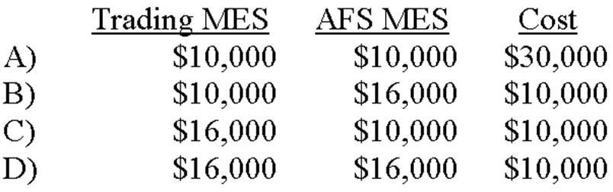
  A. | Option A
  B. | Option B
  C. | Option C
  D. | Option D

9. | Determine the amount Guido Inc. will record as an investment on its balance sheet under the three scenarios: Weiner is considered trading marketable equity security (MES), available for sale (AFS) MES, or using cost method.  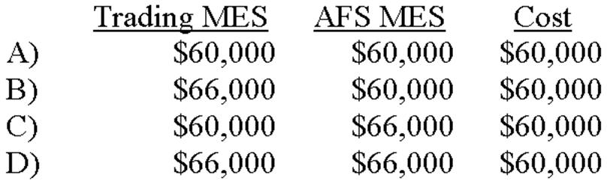
  A. | Option A
  B. | Option B
  C. | Option C
  D. | Option D

10. | Company A acquires 40% of Company B in a stock-for-stock exchange. With respect to preparing financial statements, which of the following statements is correct?
  A. | Company A will most likely use pooling-of-interest accounting for consolidation purposes.
  B. | Company A will most likely use purchase accounting.
  C. | Company A will most likely use the cost method.
  D. | Company A will most likely use the equity method.

11. | Company ABC acquires company XYZ on 12/31/06 in a share-for-share transaction worth $10 million. On 12/31/06, XYZ financial statements reported the following:  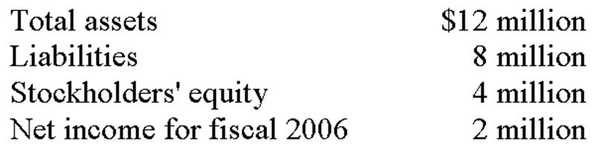  At the time of acquisition, the fair value of XYZ's assets equals its book values, except for property, plant and equipment which has a fair value $2 million higher than its book value. Goodwill is expected to be amortized over 10 years, and the average life of depreciable assets is 10 years. If ABC uses purchase accounting to record the acquisition, the amount of goodwill that will appear on its balance sheet as of 12/31/06 with respect to the acquisition of XYZ will be:
  A. | $0.
  B. | $2 million.
  C. | $4 million.
  D. | $6 million.

Chapter 6
1. | Which of the following is not a reason for economic income and accounting income to differ?
  A. | Transaction basis
  B. | The monetary assumption
  C. | Conservatism
  D. | Earnings management

2. | As a general rule, revenue is normally recognized when it is:
  A. | measurable and earned.
  B. | measurable and received.
  C. | realizable and earned.
  D. | realizable and measurable.

3. | Which of the following measures of accounting income is typically reported in an income statement?
  A. | Net income
  B. | Comprehensive income
  C. | Continuing income
  D. | All of the above

4. | According to FASB, initial franchise fees should be recognized as income when:
  A. | the franchiser has substantially performed or satisfied all material services and conditions.
  B. | the franchiser has collected the majority of fee in cash.
  C. | the franchisee shows the ability to pay the fee.
  D. | the franchiser bills the franchisee.

Brierton Company enters a contract at the beginning of year 1 to build a new federal courthouse for a price of $16 million. Brierton estimates that total cost of the project will be $12 million and will take four years to complete.
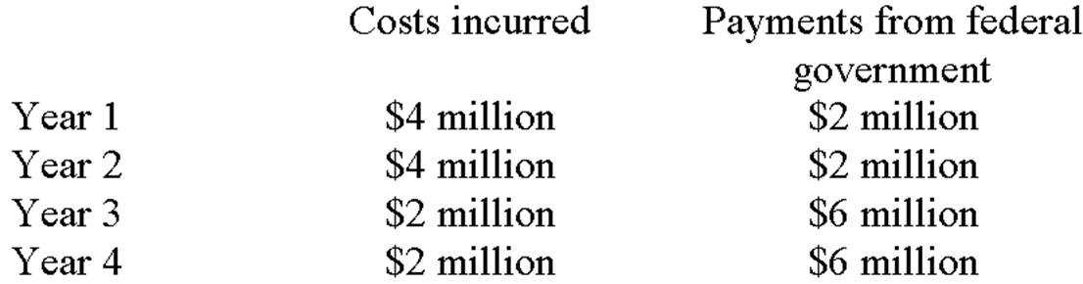

5. | If Brierton used percentage-of-completion method to account for this project, what would they have reported as profit in year 2?
  A. | $0
  B. | $1.33 million
  C. | $1.50 million
  D. | $0.67 million

6. | If Brierton used cash accounting to account for this project, what would they have reported as profit (loss) in year 2?
  A. | $0
  B. | $1.33 million
  C. | $(2 million)
  D. | $(4 million)

7. | Which of the following combinations of accounting practices will lead to the highest reported earnings in an inflationary environment?  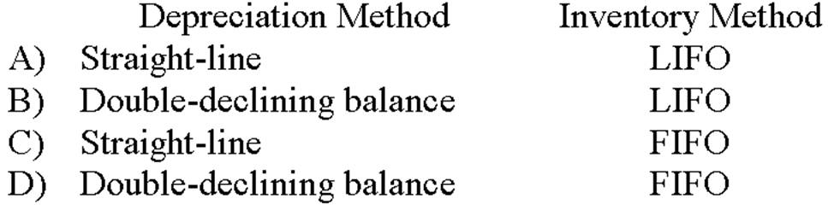
  A. | Option A
  B. | Option B
  C. | Option C
  D. | Option D

8. | Which of the following is correct?  I. If a company uses straight-line depreciation for financial reporting purposes, it is very likely they have a deferred tax liability with respect to its depreciable assets.  II. Straight-line depreciation yields an increasing rate of return on book value over the life of an asset.  III. Straight-line depreciation results in lower tax payments than accelerated depreciation methods over the life of an asset.  IV. If a company revises its estimate of the useful life of an asset upwards this will decrease annual depreciation expense.
  A. | I, II, III, and IV
  B. | I, II, and IV
  C. | I, II, and III
  D. | I and IV

9. | Which of the following statements concerning deferred taxes is correct?
  A. | Deferred taxes will not be found in the asset section of a balance sheet.
  B. | Deferred taxes arise from permanent differences in GAAP and tax accounting.
  C. | Deferred taxes will only decrease when a cash payment is made.
  D. | Deferred taxes arising from the depreciation of a specific asset will ultimately reduce to zero as the item is depreciated.

10. | Differences in taxable income and pretax accounting income that will not be offset by corresponding differences or "turn around" in future periods are called:
  A. | timing differences.
  B. | circular differences.
  C. | permanent differences.
  D. | reverse differences.

The following information was extracted from Smurm Corporation's 2006 annual report:
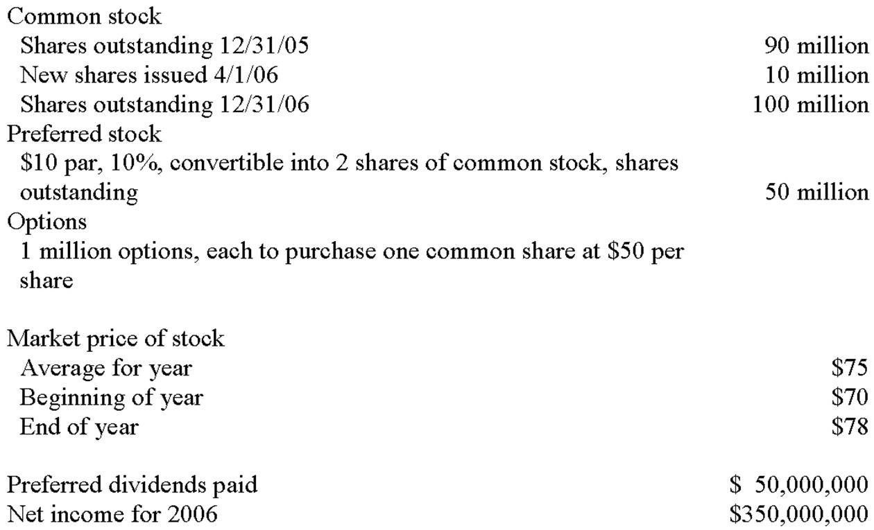

11. | Basic earnings per share for 2006 was:
  A. | $3.50.
  B. | $3.16.
  C. | $3.08.
  D. | $3.00.

