Micro Economics
Home Work 3
Chapters 10-12
PART II: THE MARKET SYSTEM
Following are 30 multiple choice questions, each worth 3.3 points. Choose the answer you think most correct. If you are uncertain about an answer, write next to the question why you think your choice is correct.
Chapter 10 Input Demands: The Labor and Land Markets
1) The idea that the demand for auto workers stems from the demand for automobiles is
A) the value of the marginal product of auto workers.
B) derived demand.
C) indirect demand.
D) output demand.

2) Demand for the lithium ion batteries used in the production of Tesla automobiles is
A) perfectly elastic.
B) unrelated to their productivity.
C) an output demand.
D) derived from the demand for Tesla automobiles.

3) Salaries of NFL quarterbacks, like Tom Brady, are
A) too high.
B) related to the additional revenues team owners expect to enjoy as a result of having them on the team roster.
C) the result of perfectly competitive markets.
D) All of the above are correct.

4) A decrease in the wage rate will change
A) only the amount of labor hired.
B) the amount of labor employed, and it may also change the amount of other inputs employed.
C) the price the firm charges for the product, but it will not affect the demand for any of the inputs.
D) the firm's profit-maximizing level output, but not its usage of inputs.

5) When a large amount of output is produced per unit of the input, the input is said to exhibit
A) high productivity.
B) low productivity.
C) marginal productivity.
D) derived productivity.

6) The demand for ________ is a ʺderived demand.ʺ
A) ice cream cones on a hot day
B) tax-free municipal bonds
C) a hair stylist by a salon owner
D) a birthday cake for your brother
7) The demand for inputs is a derived demand because
A) it does not come from competitive markets.
B) it depends on the demand for outputs.
C) it is derived from nature.
D) it is derived from production.

Refer to the data provided in Table 10.1 below to answer the following questions, 8, 9 & 10.

Table 10.1
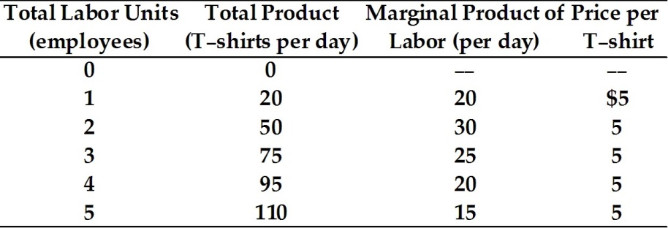

8) Refer to Table 10.1. The marginal revenue product of the fourth worker is
A) $5.
B) $20.
C) $100.
D) $475.

9) Refer to Table 10.1. The marginal revenue product of the ________ worker is $150.
A) second
B) third
C) fourth
D) fifth

10) Refer to Table 10.1. If the payment to labor per day is $100, this T-shirt manufacturer is maximizing profits if he will hire ________ employee(s).
A) one
B) two
C) four
D) five

Chapter 11 Input Demands: The Capital Market and the Investment Decision

1) Goods produced by the economic system that are used as inputs in the production of future goods and services are
A) consumable goods.
B) capital goods.
C) tangible goods.
D) depreciation goods.

2) In the capital market, households ________ supply the financial resources to firms that allow them to purchase ________.
A) indirectly; capital
B) directly; capital
C) indirectly; land
D) indirectly; labor

3) As the inventory of a firm falls
A) there is no change in its capital.
B) its intangible capital decreases.
C) its tangible capital decreases.
D) its social capital increases.

4) Firms that offer to pay for college tuition for their employees are investing in ________ capital.
A) tangible
B) productive
C) social
D) human

5) A clothing manufacturer produced 5,000 sweaters, but sold only 4,000 of them. The remaining 1,000 sweaters would be classified as
A) a loss to the firm.
B) part of the firm's tangible capital.
C) part of the firm's intangible capital.
D) a factor of production.

6) An example of tangible capital is
A) a restaurant's unsold, unopened cans of soda.
B) an idea for a new business.
C) the goodwill a firm has established through advertising.
D) knowledge of how to program a computer.

7) The measure of a firm's ________ is the current market value of its plant, equipment, inventories, and intangible assets.
A) investment
B) depreciation
C) capital stock
D) capital flow

8) A firm's capital is measured as a ________ while investment in new capital is measured as a ________.
A) flow; stock
B) stock; flow
C) stock; change
D) physical amount; dollar value

9) A university requires that all entering first-year students learn how to use word processing and spreadsheet software. This is an investment in what type of capital?
A) tangible
B) financial
C) human
D) productive

10) "Goodwill" is an example of
A) physical capital.
B) intangible capital.
C) financial capital.
D) a public service industry.

Chapter 12 General Equilibrium and the Efficiency of Perfect Competition

1) Examining the equilibrium conditions of individual markets and for households and firms separately is referred to as
A) partial equilibrium analysis.
B) general equilibrium analysis.
C) comparative statics.
D) efficiency analysis.

2) Which of the following questions is not answered by general equilibrium analysis?
A) Are equilibria in different markets compatible with one another?
B) Can all markets simultaneously be in equilibrium?
C) How will a change in one market affect another market?
D) What outcome is most desirable for the whole society?

3) It is essential to establish specific criteria to judge the performance of any economic system. One such criterion is
A) efficiency.
B) profit opportunity.
C) technological progress.
D) achieving general equilibrium.

4) Efficiency occurs when
A) the economy is producing what people want at least possible cost.
B) the economy has a fair and just distribution of income.
C) all markets are in equilibrium.
D) unemployment is low and prices are stable.

5) Resources are allocated efficiently when
A) the market produces what people want.
B) economic profits are zero.
C) output is distributed in an equitable fashion.
D) output is produced in a sustainable fashion.

Refer to the information provided in Figure 12.1 below to answer the questions 6 & 7 that follow.

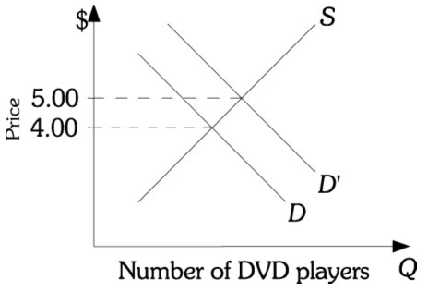
Figure 12.1

6) Refer to Figure 12.1. This firm is currently at Point A on the ATC curve. If this firm moves toward Point B, this will make the
A) distribution of outcome more equitable.
B) economy more stable.
C) economy more efficient.
D) economy less stable.

7) Refer to Figure 12.1. The firm is
A) equally efficient when it produces at points A and B.
B) more efficient when it produces at point A than at point B.
C) more efficient when it produces at point B than at point A.
D) producing at least possible cost anywhere along the given ATC curve.

Refer to the information provided in Figure 12.2 below to answer the questions 8 & 9 that follow.

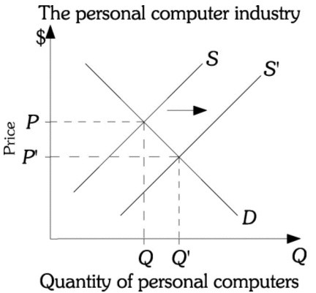
Figure 12.2

8) Refer to Figure 12.2. A technological advance causes the supply of personal computers to increase. The graph of this situation represents a
A) general equilibrium analysis because it identifies what happens to both equilibrium price and quantity of personal computers.
B) partial equilibrium analysis because it considers only this one industry.
C) firm-specific analysis because only one firm would be affected by the technological advance.
D) technological analysis because the change resulted from a technological advance.

9) Refer to Figure 12.2. The graph of this situation represents a partial equilibrium analysis because it
A) only shows a change in supply.
B) considers only the personal computer industry.
C) shows changes to both price and quantity.
D) only shows two possible equilibrium points.

10) A technological change in the production of cars will
A) affect only the markets for inputs used to produce cars.
B) affect only the way cars are produced.
C) have no effect on consumers.
D) affect input and output markets in the automobile industry and other related industries.

