https://jobs.nrf.com/
https://nrffoundation.org/
Below are links to internships with retail chains that are members of the NRF, the US’s largest organization of retailers. Students interested in being accepted for an internship at one of the locations below needs to follow the link and follow the procedures the Sponsor calls for. For assistance, contact Mr. Humphries at humphires@bezeqint.net or 054-5316157.

Each of the internships below is for the Summer of 2020. You need to apply during the fall semester to be accepted. So, research the internships that look interesting to you and start applying this fall.
Distribution Operations InternshipTJX Companies, Inc. – Bloomfield, CT, United States

- Distribution Operations InternshipTJX Companies, Inc. – Jefferson, GA, United States

- Distribution Operations InternshipTJX Companies, Inc. – Tucson, AZ, United States

- Distribution Operations InternshipTJX Companies, Inc. – Brownsburg, IN, United States

- Distribution Operations InternshipTJX Companies, Inc. – Atlanta, GA, United States

- Distribution Operations InternshipTJX Companies, Inc. – Phoenix, AZ, United States

- Distribution Operations InternshipTJX Companies, Inc. – Pittston, PA, United States

- Distribution Operations InternshipTJX Companies, Inc. – Woburn, MA, United States

- Distribution Operations InternshipTJX Companies, Inc. – Worcester, MA, United States

  - Merchandise Analyst - Pottery Barn KidsWilliams-Sonoma – San Francisco, CA,

- information security analyst, Information Technology, Security, Scottsdale, AZStarbucks – Scottsdale, AZ, United States

- IT InternBurlington – Edgewater Park, NJ, United States

- UK Wholesale e-Commerce InternRalph Lauren – London, NA, United Kingdom

- Sales Analytics Intern (6 months duration) *internship agreement mandatory*Ralph Lauren – Plan-les-Ouates, NA, Switzerland

- Retail Performance Marketing Intern - 12 MonthsRalph Lauren – London, NA,

- Distribution Center Intern - Chambersbrug, PAUlta Beauty – IL, United States

- E-Commerce InternBurlington – Burlington, NJ, United States

- Finance InternBurlington – Burlington, NJ, United States
- InternTJX Companies, Inc. – Evansville, IN, United States

- Planning & Allocations InternBurlington – Burlington, NJ, United States
- Ralph Lauren Stores - Sales ProfessionalRalph Lauren – Paris, NA, United States

- senior iOS engineer, Starbucks Technology Center - Scottsdale, AZStarbucks – Scottsdale, AZ, United States

- Human Resources Assistant (Intern)TJX Companies, Inc. – Decatur, GA, United States

- 2019 Intern Conversion:2020 Full-Time Sr. Manager - InsightsWalmart –

- Praktikum im Bereich OnlinemarketingRalph Lauren – Munich, NA, Germany
- Merchandise Analyst, Pottery Barn Kids & Teens - Global AustraliaWilliams-Sonoma – San Francisco, CA, United States

- 2019 Intern Conversion: 2020 Full-Time MBA Marketing Associate ManagerWalmart – BENTONVILLE, AR, United States

  - Intern Sales Controlling & Business DevelopmentRalph Lauren – Munich, NA,

- eCommerce MBA Manager Intern ATL1 �?? Summer 2020Walmart – ATLANTA, GA, United States

- eCommerce MBA Manager Intern LAX2 - Summer 2020Walmart – CHINO, CA, United States

- eCommerce MBA Manager Intern PHL2 - Summer 2020Walmart – BETHLEHEM, PA, United States
- Assistant Buyer Intern (Los Angeles)Ross Stores, INC – Los Angeles, CA, United States

- Summer 2020 Intern - Buying or PlanningRoss Stores, INC – New York, NY, United States

- 2019 Intern Conversion: 2020 Full time Designer - TechWalmart – BENTONVILLE, AR, United States

- 2019 Intern Conversion: 2020 Full time Software Engineer 2 (Reston)Walmart – BENTONVILLE, AR, United States

- 2019 Intern Conversion: 2020 Full time Software Engineer 2-TechWalmart – BENTONVILLE, AR, United States

- 2019 Intern Conversion: 2020 Full time Software Engineer 3 - TechWalmart – BENTONVILLE, AR, United States
- 2019 Intern Conversion: 2020 Full time Associate Designer - TechWalmart – BENTONVILLE, AR, United States

- 2019 Intern Conversion: 2020 Full time Software Engineer 2 (Reston)Walmart – BENTONVILLE, AR, United States

- OD Intern - Bennington, VTWalmart – BENNINGTON, VT, United States

- Pre-Grad Intern-WMWalmart – STURGEON BAY, WI, United States

- Field Intern - Store #2644 Saginaw, MIWalmart – SAGINAW, MI, United States

- OD Intern - Glenmont, NYWalmart – GLENMONT, NY, United States

- 2019 Intern Conversion: 2020 Soft Eng I, Supply Chain Tech RESTONWalmart – BENTONVILLE, AR, United States

- 2019 Intern Conversion: 2020 Soft Eng II, Supply Chain Tech RESTONWalmart – BENTONVILLE, AR, United States

- 2019 Intern Conversion: 2020 Full time Data Scientist - TechWalmart – BENTONVILLE, AR, United States

- eCommerce MBA Manager Intern IND1-Summer 2020Walmart – PLAINFIELD, IN, United States

- eCommerce MBA Manager Intern LAX1 �?? Summer 2020Walmart – CHINO, CA, United States

- eCommerce MBA Manager Intern DFW1-Summer 2020Walmart – FORT WORTH, TX, United States

- eCommerce MBA Manager Intern MCO1 �?? Summer 2020Walmart – DAVENPORT, FL, United States
eCommerce MBA Manager Intern PHL1 �?? Summer 2020Walmart – BETHLEHEM, PA, United States

- Lead Supply Chain Coordinator - Williams SonomaWilliams-Sonoma – San Francisco, CA, United States

- Supply Chain Coordinator - Williams SonomaWilliams-Sonoma – San Francisco, CA, United States
IF YOU’RE SERIOUS ABOUT A RETAIL CAREER
If you are serious about the above internships and want to enhance your chances of obtaining one of them, I suggest you take the three courses offered by the National Retail Federation Foundation at https://nrffoundation.org/
The courses are RiseUP courses (see below) and located on the landing page: page down a little and you’ll see them. The courses are the retail industry’s standards for their respective topics. Completing these three courses shows potential employers that you are serious about a retail career and aren’t just taking a random shot at an internship.
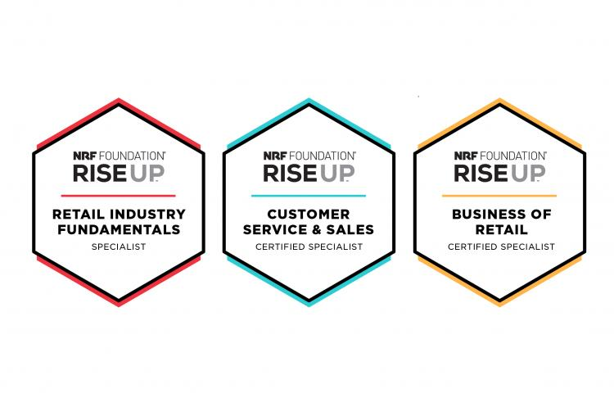
When you interview for a job, the interviewer is actually interested in how much you know about the industry: can you carry a conversation about the industry and its contemporary issues? Cramming for the interview a few days ahead of the interview won’t fool these people. Instead, if you want to be ahead of the game, sign up for their newsletter, SmartBrief, and keep up with events as they happen at https://nrf.com/. Read the blogs on the page, STORES Magazine, etc. You get the point.

